**Test a Perceptual Phenomenon**

Background Information

In a Stroop task, participants are presented with a list of words, with each word displayed in a color of ink. The participant’s task is to say out loud the *color of the ink* in which the word is printed. The task has two conditions: a congruent words condition, and an incongruent words condition. In the *congruent words* condition, the words being displayed are color words whose names match the colors in which they are printed: for example RED, BLUE. In the *incongruent words* condition, the words displayed are color words whose names do not match the colors in which they are printed: for example PURPLE, ORANGE. In each case, we measure the time it takes to name the ink colors in equally-sized lists. Each participant will go through and record a time from each condition.

**Raw Data in seconds for each test:**

|  |  |  |
| --- | --- | --- |
|  | **Congruent** | **Incongruent** |
| **0** | 12.079 | 19.278 |
| **1** | 16.791 | 18.741 |
| **2** | 9.564 | 21.214 |
| **3** | 8.63 | 15.687 |
| **4** | 14.669 | 22.803 |
| **5** | 12.238 | 20.878 |
| **6** | 14.692 | 24.572 |
| **7** | 8.987 | 17.394 |
| **8** | 9.401 | 20.762 |
| **9** | 14.48 | 26.282 |
| **10** | 22.328 | 24.524 |
| **11** | 15.298 | 18.644 |
| **12** | 15.073 | 17.51 |
| **13** | 16.929 | 20.33 |
| **14** | 18.2 | 35.255 |
| **15** | 12.13 | 22.158 |
| **16** | 18.495 | 25.139 |
| **17** | 10.639 | 20.429 |
| **18** | 11.344 | 17.425 |
| **19** | 12.369 | 34.288 |
| **20** | 12.944 | 23.894 |

**What is the independent variable? What is the dependent variable?**

**Independent variable** - the two conditions - congruent words, and incongruent words.  
**Dependent variable** - reaction time in each of the two conditions. What is an appropriate **What is an appropriate set of hypotheses for this task? Specify your null and alternative hypotheses, and clearly define any notation used. Justify your choices.**

**Hypotheses:**

Null hypotheses, 𝐻0H0 - the reaction time of the congruent words condition is greater than or equal to the incongruent words condition: 𝜇𝑐𝑜𝑛𝑔𝑟𝑢𝑒𝑛𝑡≥𝜇𝑖𝑛𝑐𝑜𝑛𝑔𝑟𝑢𝑒𝑛𝑡μcongruent≥μincongruent

Alternate hypotheses, 𝐻𝐴HA - the reaction time of the congruent words condition is less than the incongruent words condition: 𝜇𝑐𝑜𝑛𝑔𝑟𝑢𝑒𝑛𝑡<𝜇𝑖𝑛𝑐𝑜𝑛𝑔𝑟𝑢𝑒𝑛𝑡μcongruent<μincongruent

Where: 𝜇𝑐𝑜𝑛𝑔𝑟𝑢𝑒𝑛𝑡μcongruent - Mean of congruent reaction times in seconds, 𝜇𝑖𝑛𝑐𝑜𝑛𝑔𝑟𝑢𝑒𝑛𝑡μincongruent - Mean of incongruent reaction times in seconds

To determine if list congruity has any effect on reaction time the Recommended statistical test are dependent samples t-test, one-tailed and negative. it suffices to test hypothesis #2. It is a broader statement that makes no assumptions as to which mean is greater. Since we do not have information on population parameters, a **dependent samples t-test** will be appropriate to test the alternative hypothesis against the null. By examining how the sample means differ from each other, we will be able to make a determination about how the population means differ. The samples are dependent because each participant is timed twice: once with the congruent list and once with the incongruent list.

After doing the test myself on the [interactive Stroof Effect website](https://faculty.washington.edu/chudler/java/ready.html), it took me congruent = 13.287 secs, incongruent = 27.269 secs. I expect to reject the null hypothesis and come to the conclusion that it takes significantly longer to identify colors where the text does not match the ink. But I am a sample size of one, so we will need to examine a larger sample to establish this.

**Report some descriptive statistics regarding this dataset. Include at least one measure of central tendency and at least one measure of variability. The name of the data file is 'stroopdata.csv'.**

* Mean -
  + Congruent = 14.05 secs
  + Incongruent = 22.02 secs
* Standard deviation -
  + Congruent = 3.56 secs
  + Incongruent = 4.80 secs
* Median -
  + Congruent = 14.36 secs
  + Incongruent = 21.02 secs

**Provide one or two visualizations that show the distribution of the sample data. Write one or two sentences noting what you observe about the plot or plots.**

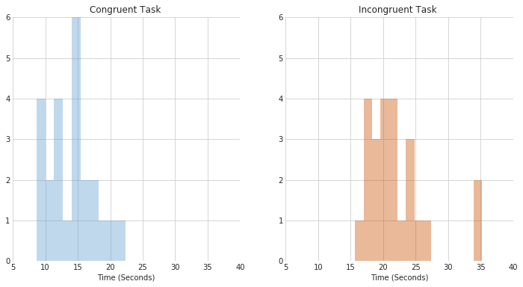

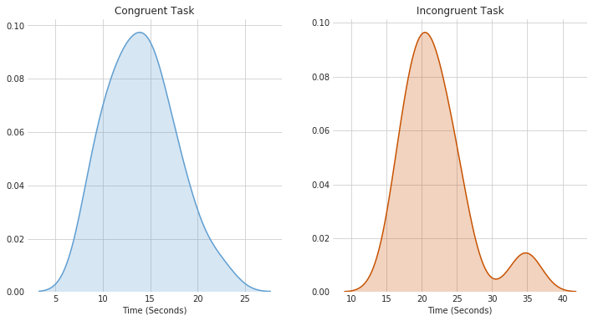

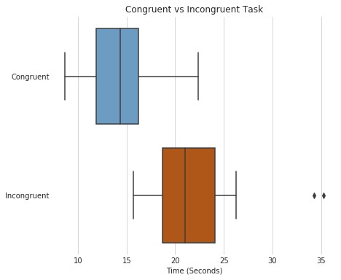

**Observations:**

1. Distribution of congruent and incongruent times are dense around the median and less spread out.
2. It is easily noticeable that the incongruent times are considerably higher than congruent times.

**Now, perform the statistical test and report your results. What is your confidence level or Type I error associated with your test? What is your conclusion regarding the hypotheses you set up? Did the results match up with your expectations? Hint: Think about what is being measured on each individual, and what statistic best captures how an individual reacts in each environment.**

4.8648269103590556

𝑠𝑐−𝑖=4.86sc−i=4.86 secs

-7.96479166667 0.993028634778 Ttest_relResult(statistic=-8.020706944109957, pvalue=4.1030005857111781e-08)

𝑥¯𝑐−𝑥¯𝑖=−7.96x¯c−x¯i=−7.96 secs

S.E. = 0.99 secs

𝑡𝑠𝑡𝑎𝑡=−8.021tstat=−8.021

P-value = 0.00000004

t(23) = -8.021, p=.00, one-tailed

𝛼=0.01α=0.01 i.e. confidence level = 99%

𝑡𝑐𝑟𝑖𝑡𝑖𝑐𝑎𝑙=−2.500tcritical=−2.500

**Decision: Reject**𝐻0H0**i.e. Reject - "the reaction time of the congruent words condition is greater than or equal to the incongruent words condition"**

**This means, that the reaction time of the congruent words condition is significantly less than the incongruent words condition.**

**Conclusion**

We see that the average time of sample under congruent conditions is different from the average time of sample under incongruent conditions. My confidence level is .001(0.1%), and since the degree of freedom is n - 1 which is 23, my critical statistic value is ± 3.768. Also, I reject the null hypothesis. Finally, as I expected when I saw the boxplot, the results from t-test match up with my expectations.

**Optional: What do you think is responsible for the effects observed? Can you think of an alternative or similar task that would result in a similar effect? Some research about the problem will be helpful for thinking about these two questions!**

I think the reason of the Stroop effect is because in the incongruent word condition the words distract the attention. According to Wikepedia, the Simon effect is similar to the Stroop effect. The Simon effect refers to the finding that reactions are faster and accurate when stimulus occurs in the same relative location.

**Resources:**

Udacity Forums  
Udacity nanodegree videos   
<http://www.graphpad.com/quickcalcs/>   
<http://www.ats.ucla.edu/stat/mult_pkg/faq/general/tail_tests.htm>  
<http://www.statstutor.ac.uk/resources/uploaded/paired-t-test.pdf>   
<https://www.ltcconline.net/greenl/courses/201/descstat/mean.htm>